[Cámaras] Olympus CAMEDIA C-5060 Wide Zoom
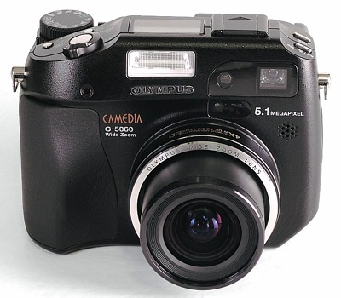
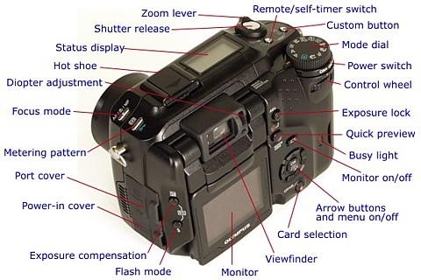
 Enlaces
- Páginas web
  - C-5050Z, C-5060WZ and C-7070WZ, The last great compact cameras from Olympus
  - Olympus C-5060WZ digital camera - How does it compare with the original '5050?
  - Olympus Camedia C-5060WZ, A Technical Review (with notes on the C-7070WZ)
- Vídeos
  - Something different: Olympus Camedia C-5060 review

