[Cámaras] Olympus CAMEDIA C-5060 Wide Zoom
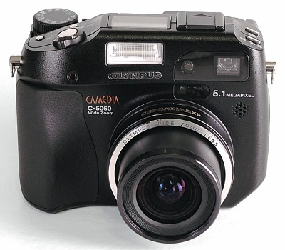
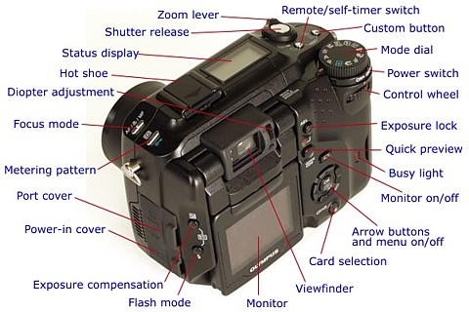
 Enlaces
- C-5050Z, C-5060WZ and C-7070WZ, The last great compact cameras from Olympus
- Olympus Camedia C-5060WZ, A Technical Review (with notes on the C-7070WZ)

